**Assignment**: (MySQL) - Assignment ID: 08_MySQL_Assignment2

**1. Write a query to retrieve the book and its subject details using inner join**

SELECT

bk.bookId, bk.title, bk.price, bk.volume, bk.publishDate,

sub.subjectId, sub.subtitle, sub.durationInHours

FROM

cogdb.book bk inner join cogdb.subject sub

ON

bk.bookId = sub.bookId;

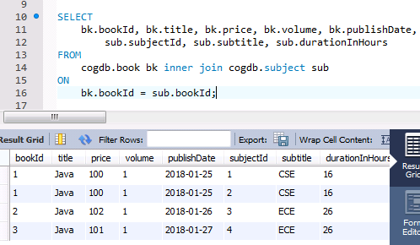

**2. Write a query to retrieve the books list published in a given specific date interval**

SELECT

bookId, title, price, publishDate

FROM

cogdb.book where publishDate > '2018-01-25' AND publishDate < '2018-01-28';

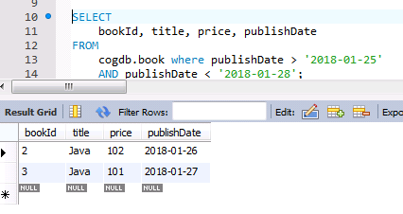

**3. Write a query to retrieve the number of books referred by each subject**

**where the subject tite starts with a specific character (say ‘j’ f**

**or instance)**

SELECT

count(bk.bookId) from cogdb.book bk, cogdb.subject sub

WHERE

bk.bookId = sub.bookid and sub.subtitle like 'J%';

